Topology Prelim, Winter 2001

Problems
- Let $C$ be the union of line segments in $R^{2}$ from $(0,1)$ to $(1/n,0)$ for $n=1,2,3,…$ and the line segment from $(0,1)$ to $(0,0)$. Show that there is no contraction of $C$ that keeps $(0,0)$ fixed at all times.
- How many path components does the group of $2×2$ invertible matrices, $GL(2,R)$ have?
- Let $X$ and $Y$ be metric spaces and let $f:X×I→Y$ be a homotopy. Define $D(t)$ to be the diameter of the set $f_{t}(X)$ (that is, it is the supremum of the distances between pairs of elements in the subset $f_{t}(X)$ of $Y$). Show that if $X$ is compact then $D$ is continuous. Show by example that without this assumption, $D$ may not be continuous even if $Y$ is compact.
- Let $A$ be a submanifold of a manifold $M$. Give necessary and sufficient conditions for the existence of a covering space map $p:M^{'}→M$ such that $p^{-1}(A)$ is not connected.
- Compute $H_{*}(X)$ where $X$ is the disk $D^{2}$ with three arcs identified as drawn below.
- 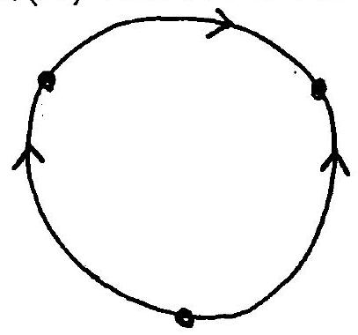
- Let $S$ be a surface of genus $2$. Show that the natural map $π_{1}(S,*)→H_{1}(S)$ has a non-trivial kernel.
- Let $S^{1}=\{v∈R^{2}∣|v|=1\}$. Suppose $f:S^{1}→R^{2}-0$ is continuous and $v⋅f(v)>0$ for all $v∈S^{1}$. Prove that $f$ does not extend to a function from $D^{2}$ into $R^{2}-0$.
- Prove that $S^{1}$ is not contractible. (Give a fairly detailed sketch of any facts you use.)

